Temple University College of Engineering

Department of Electrical and Computer Engineering (ECE)

**Course Number : ECE 4612**

**Course Section : 001**

**Programming Assignment # : 1**

**Student Name (print) : Jon Eskow**

**TUid# : 915222192**

**Date : 09/30/16**

*Objective:*

The objective of this assignment was to familiarizes ourselves with the MIPS assembler by running several sample programs and writing three programs of our own. The sample programs were meant to be used as a reference that we could use in our own programs, we were also given several procedures to aid us in writing the code and combining everything together to finish the tasks that were assigned to us.

*Tools*:

The tools that were used was the MARS (MIPS Assembler and Runtime Simulator) IDE v4.5 meant for use with the Patterson and Hennessy *Computer Organization and Design* text. We also used our own computers to write and assemble the code. The computer that was used for the project in this particular write up was a Toshiba Satellite E45-B running Windows 10 with an Intel i5 processor running at 1.70GHz with potential boost of 2.4GHz.

*Procedure/Analysis:*

Task 1:

To start I ran the sample programs, HelloWorld (figure 1), Rtype(Figure 2), IntegerInput2Register(Figure 3), Print_Integer2Console(Figure 4), and StringInput_Output(Figure 5) and familiarized myself with the syntax used in each of these programs. I then used these programs as a guide to write and implement the following examples.

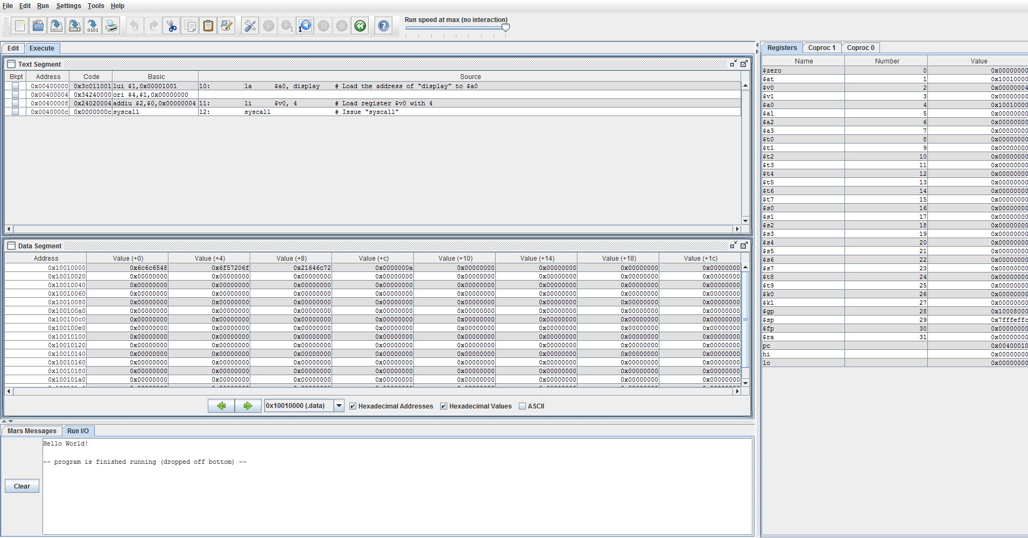

*Fig 1. Output of HelloWorld program showing IO window*

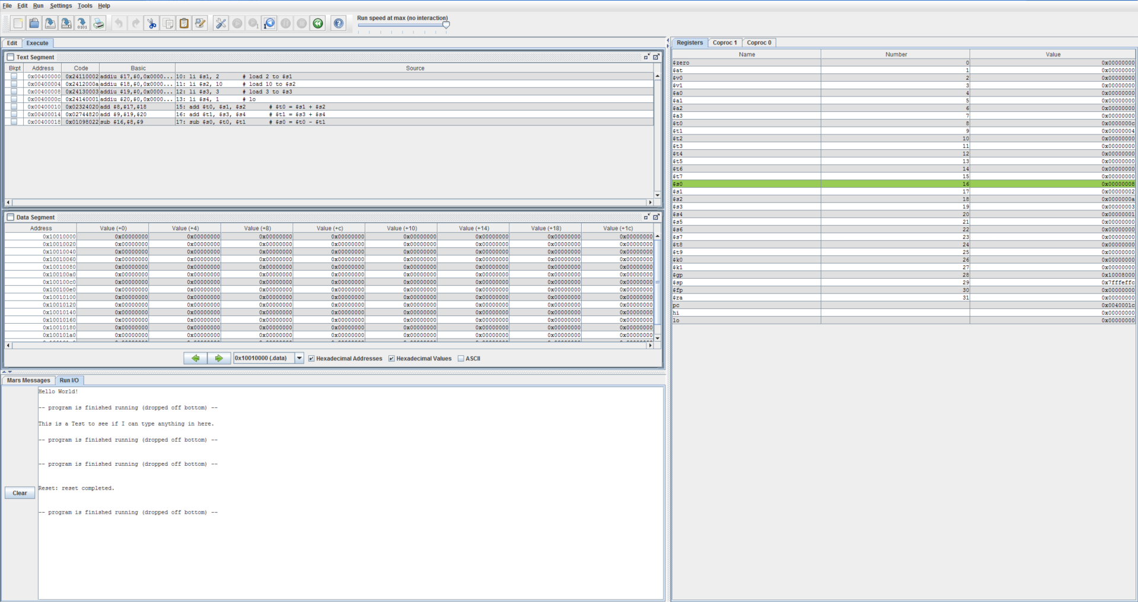

*Fig. 2 Output of RType program showing operands and results*

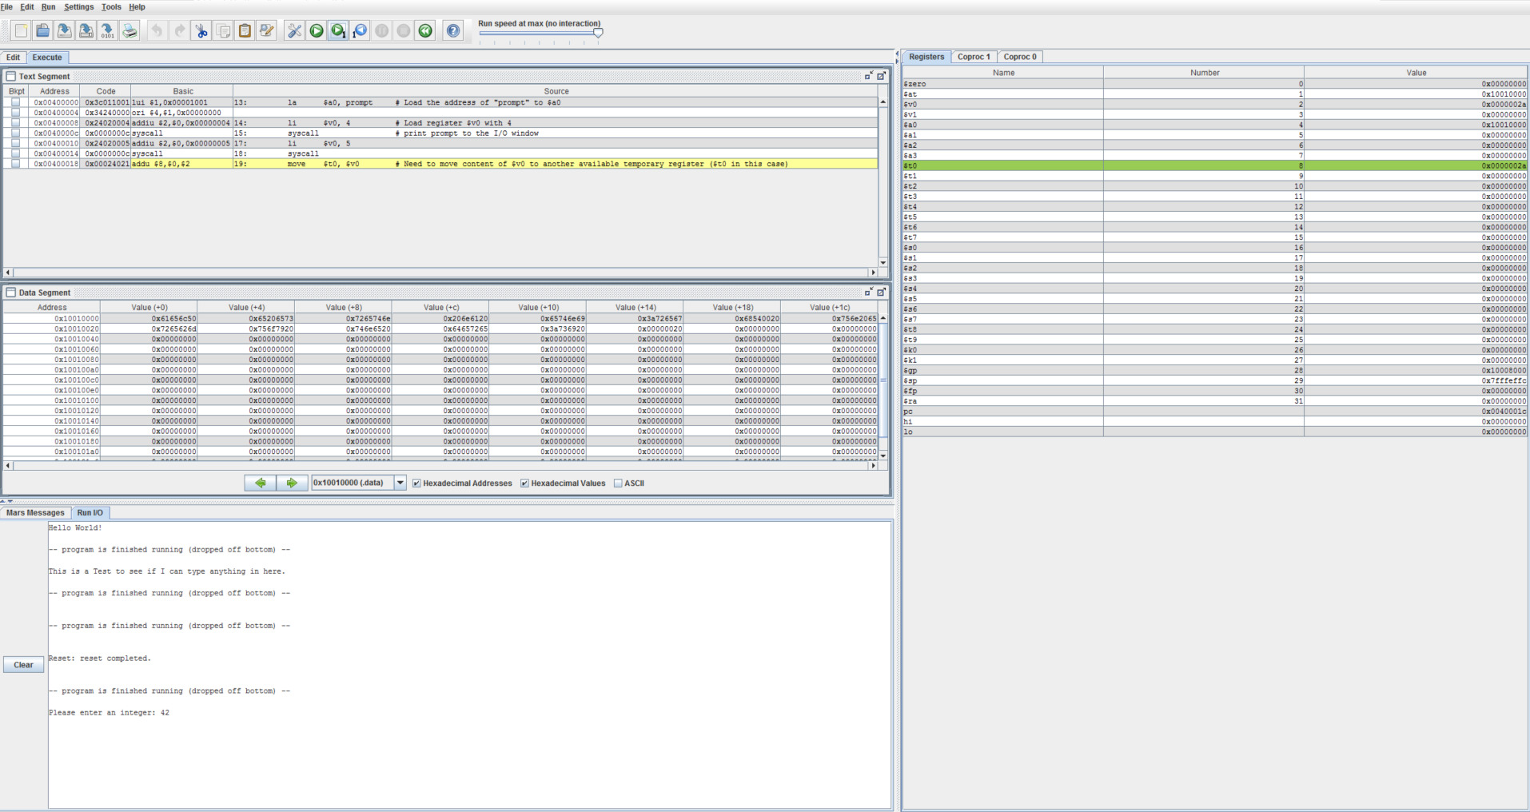

*Fig. 3 Input and Output of IntegerInput2Register program*

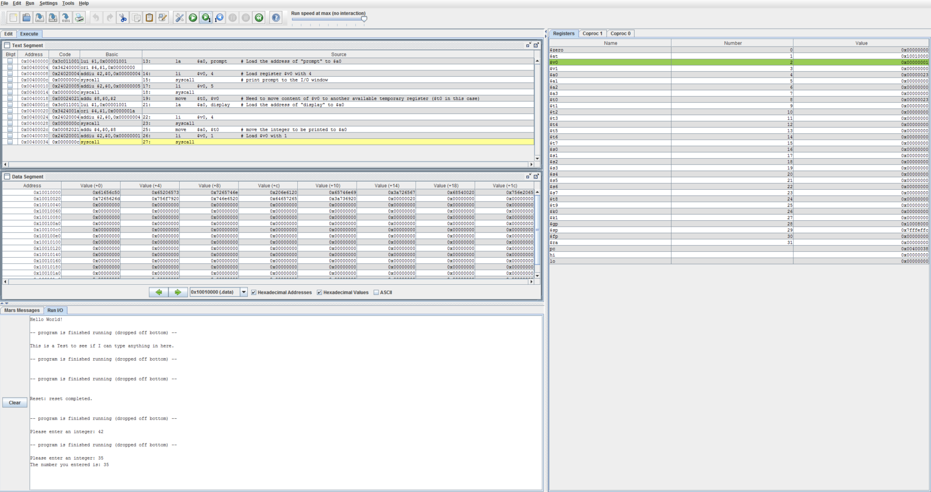

*Fig 4. Input and Output of program Print_Integer2Console*

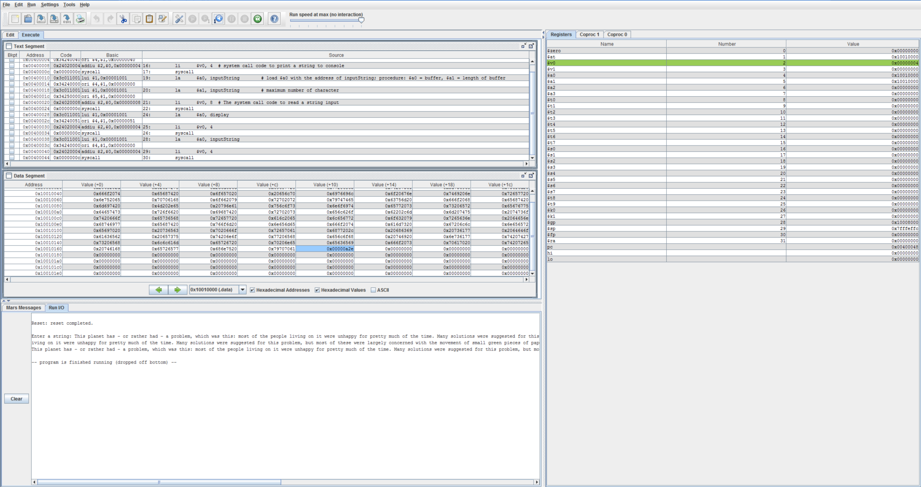

*Fig 5. Input and Output of program StringInput_Output*

Task 2:

For Task 2, we had to write MIPs code that allowed a user to enter a string, load it into an array, and then copy that array to a second array. We were given the copy procedure and were tasked to write the support code to prompt the user to enter the integer. While it was unclear if the copy completely worked by inspection of the Data Segment window, upon completion, the registers a0 and a1 (figure 6) contained the same value. As x and y were in registers a0 and a1 respectively, this was taken as a positive sign that the program did in fact work as an array is just an address that contains data. The program copied the address that contained x and copied it into y.

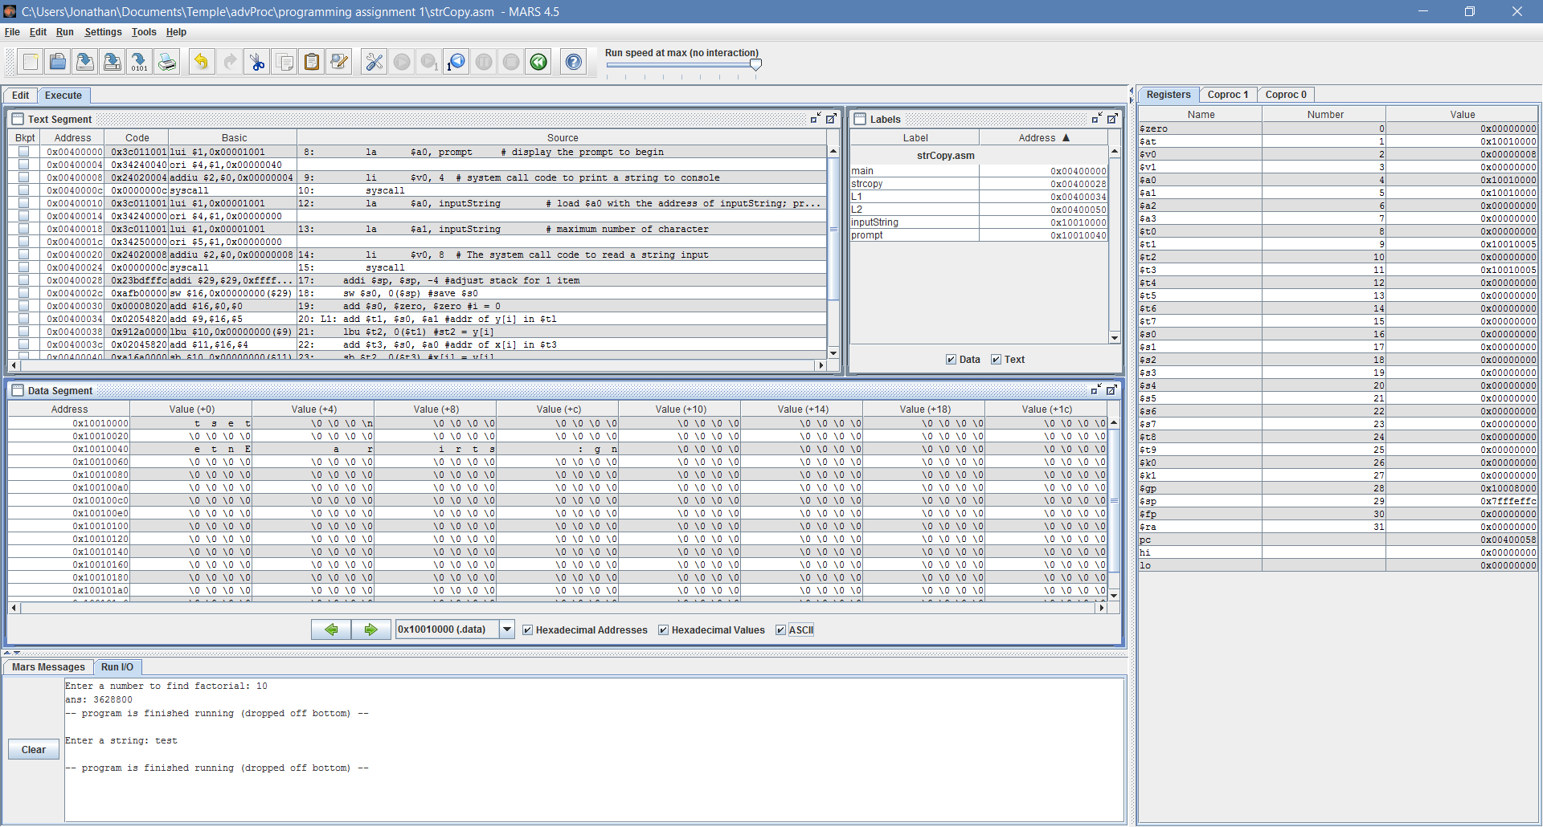

Fig. 6 Registers a0 and a1 have same value of 0x10010000 , the same address of the input string as seen in the Data Segment portion of the screen.

Task 3:

For Task 3 we had to take an Integer input, run a factorial calculation on it, and output the value. Similar to the other tasks we were given a piece of startup code and wrote support code to allow a user input and provide an easy to read output. The solution to this task borrowed from the two integer sample programs and then rewrite some of the code to make sure the inputs and outputs are going to and from the right registers. While running some quick tests, it was found that if the factorial was too great the output would be a negative number. This makes sense as the integers being input and output are not specified as “unsigned” so the output would be a signed number and if the number is large enough the register outputting the answer is going to get confused and show the factorial of the input as a negative. This could be remedied by specifying all values as unsigned integers.

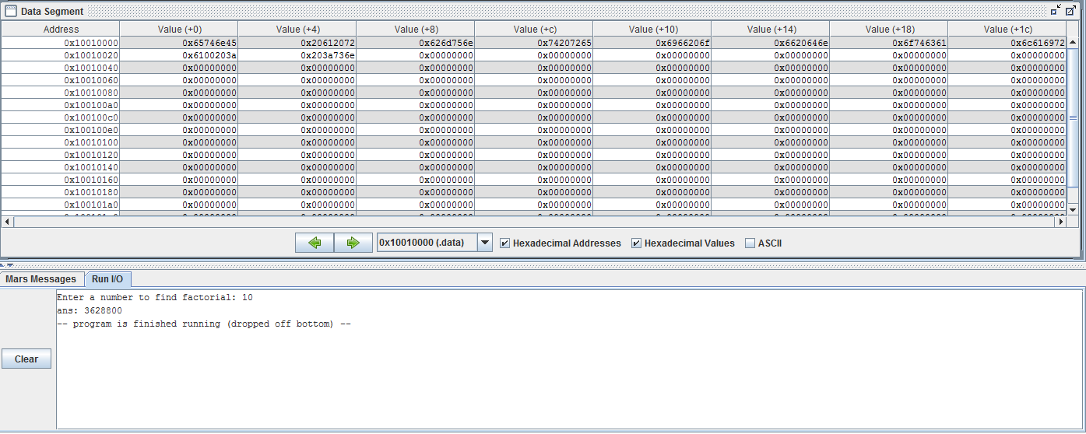

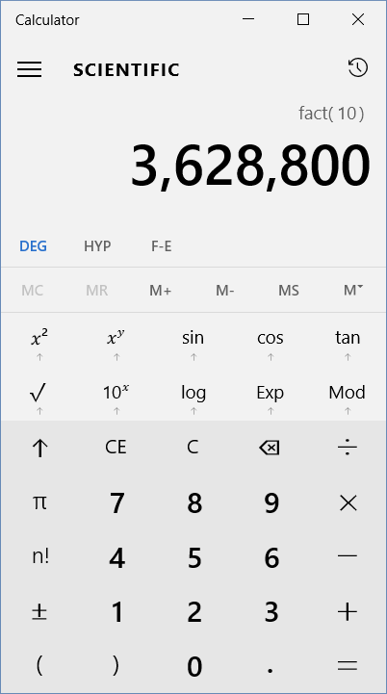

Fig 7: Output of factorial program along with windows calculator to confirm the arithmetic is correct.

Task 4:

The final task was to insert a series of 5 integers and return them sorted. In this example we were given a piece of code that performs a bubble sort on a series of integers. The algorithm in C is  
  
void sort (int v[], int n)

{

int i,j;

for (i = 0; i < n ; i ++)

{

for (j = i-1; j >= 0 && v[j] > v[j+1]; j--)

{

swap(j,i);

}

}

}

It takes a value and compares that value with the next value in the array and if one is smaller than the other, then the positions in the array of both elements are swapped. I was unable to get my own version of this program to work. I tried to solve it by giving several prompts to load places on the stack with integers and while the bubble sort works, my implementation fails in the output because all values are just popped off the stack and are never read out to the IO window.

*Conclusion*:

MIPS is one of the most common architectures in use and Assembly language allows the designer and programmer to intimately work within the system with maximum control over everything that happens at the register level. Additionally, assembly provides the designer more space as there are no complex compilers to work with providing a means of maximizing procedure and minimizing space. That said, coding in assembly is arduous and complex programs end up having many times more lines of code than a higher level (i.e. C) script which also can lead to a higher probability of mistakes. Assembly is effective if used appropriately, but just because a program is written in assembly doesn’t mean it will take up less space and processing power than a similar program written in a higher level language as an algorithm written in assembly could be half as efficient as an algorithm written in higher level languages through sheer lack of understanding on the programmer’s part. Assembly is a tool, and as with any other tool, it must be used properly to be effective.